Phys 216 HW5 – pt2

Nicholas Pun

27872167

Q1. The file *“ballistics - Nicholas Pun.py”* contains the code for my ballistic rocket trajectory simulator.

Q2. The following were run with dt = 0.001 to achieve accuracies of at least the nearest metre.

* Alt = 60o and Azimuth = 0o

Hit the ground at T = 32.91473378248321 s with

vx,vy,vz = [ 0.40030583 114.76356268 -83.41360682] m/s and

x,y,z = [1.16906452e+01 8.37800434e+03 6.93889390e-18] m

* Alt = 70o and Azimuth = 90o

Hit the ground at T = 58.280432511222855 s with

vx,vy,vz = [ 33.23212488 -0.60097484 -135.50742725] m/s and

x,y,z = [9303.91168236 -67.65714145 0. ] m

* Alt = 80o and Azimuth = 180o

Hit the ground at T = 155.64982783252472 s with

vx,vy,vz = [ 0.19104299 -3.27439882 -151.73792712] m/s and

x,y,z = [ -182.96801662 -16037.01509193 0. ] m

* Alt = 89o and Azimuth = 270o

Hit the ground at T = 126.10413174595541 s with

vx,vy,vz = [ -0.31403641 -0.30416605 -151.40100278] m/s and

x,y,z = [-1330.90077771 -118.36554361 0. ] m

Q3. The following are plots for Alt = 80o and Azimuth = 180o run with dt = 0.001.

* X-Y trajectory

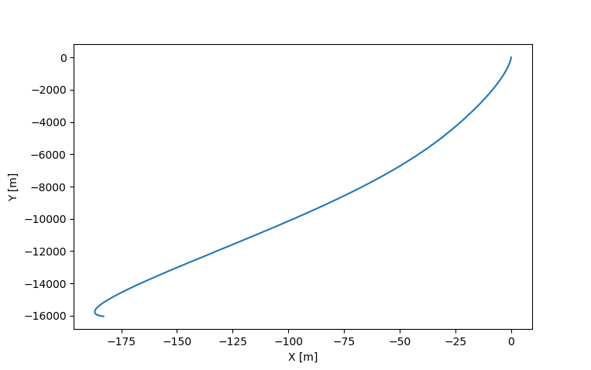

The rocket starts at (x,y) = (0,4) in the top right then initially travels southwards. Due to the rotation of the Earth, the rocket is accelerated westwards. Near the end of its trajectory there is a small hook where the rocket is accelerated eastwards. I believe that this section is where the rocket is falling, and as its speed increases, the drag force against the rocket’s direction of motion also increases. Since the rocket has some velocity in the westward direction, there is some acceleration due to drag on the rocket in the eastward direction. The turning point is then the point where the speed has become large enough such that the magnitude of the acceleration due to drag becomes larger than the magnitude of the acceleration due to the rotation of the Earth.

* Magnitude of the velocity as a function of time

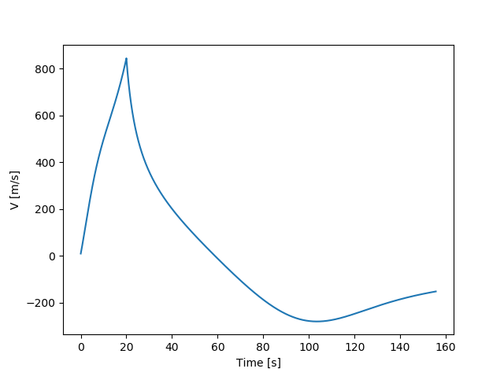

At time zero the velocity is 10 m/s and increases very quickly due to the large acceleration given by the thrust of the fuel. This increase is not linear as the acceleration is decreasing. At this section of the plot, the positive acceleration of the thrust is greater than the negative acceleration of the drag but only increasing inversely proportional to the rocket’s mass, whereas the negative acceleration of the drag is decreasing (more negative) proportionally to the velocity squared, and thus the slope is positive but decreasing.

Then when the rocket runs out of fuel at 20s, the thrust is suddenly zero and so the slope (acceleration) is instantaneously negative.

From approximately 20s – 60s the rocket is slowing down and thus the magnitude of the drag force is decreasing, and thus the magnitude of the acceleration is decreasing, hence why the slope is negative but increasing.

From approximately 60 – 80s the rocket has turned around and is now falling. This means the speed is increasing and thus the magnitude of the drag is increasing and against the motion, hence why the slope is negative but increasing.

After about 100s the acceleration becomes positive again. I believe this is the same point as the hook in the X-Y plot, and its reasoning is the same as before.

* Magnitude of the acceleration as a function of time

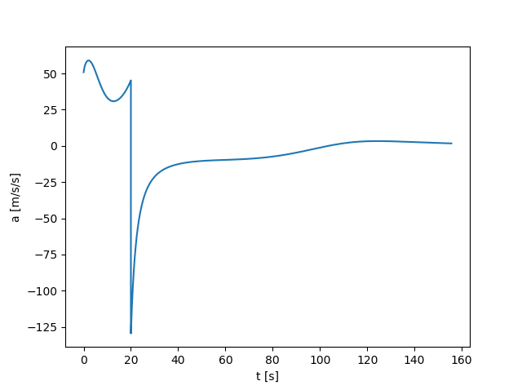

The rocket instantaneously starts with a positive acceleration of around 50 m/s^2 from the thrust of the fuel but decreases due to the drag force scaling quicker than the thrust force, hence why the acceleration increases then decreases.

However, at a certain altitude the magnitude of the drag force becomes smaller as the atmosphere becomes thinner and thus the thrust force once again overtakes the drag force, hence why the acceleration decreases then increases.

At 20s there is no more fuel and thus the positive acceleration of the thrust is gone, hence why the acceleration suddenly drops to negative.

From 20s onwards the acceleration increases, initially very quickly. Since the rocket is slowing down quickly, and the magnitude of the negative acceleration due to drag quickly decreases, hence the acceleration is negative but increasing. Furthermore, the magnitude of the drag force decreases exponentially, and thus the slope of the acceleration decreases.

After 60s the rocket is falling and thus the acceleration due to drag is positive, again increasing the acceleration. The magnitude of the drag force is increasing exponentially and thus the slope of the acceleration is increasing.

At around 100s onwards the curvature of the graph is again negative. This is where I believe the drag acceleration overtakes the acceleration of the rotation of the Earth. At the point where acceleration equals 0 is the point at which the rocket as reached terminal velocity.

* Height as a function of time

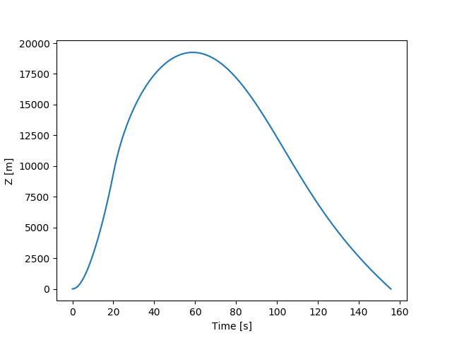

The rocket begins with at a height of 4 m. The height increases non-linearly as the acceleration is positive until 20s.

At 20s the rocket is still increasing in height, but the acceleration has switched from positive to negative, and thus the curvature of the graph becomes negative.

After 60s the rocket is falling, but its height doesn’t change as rapidly as during its climb because the magnitude of the acceleration due to gravity is not as large as the magnitude of the acceleration due to the thrust, hence why the graph is not as steep in this region.

After around 100s the curvature of the slope becomes positive, meaning the acceleration has become positive. I believe this is because the magnitude of the acceleration due to the drag overtakes the magnitude of the acceleration due to the rotation of the Earth.

* Height as a function of range

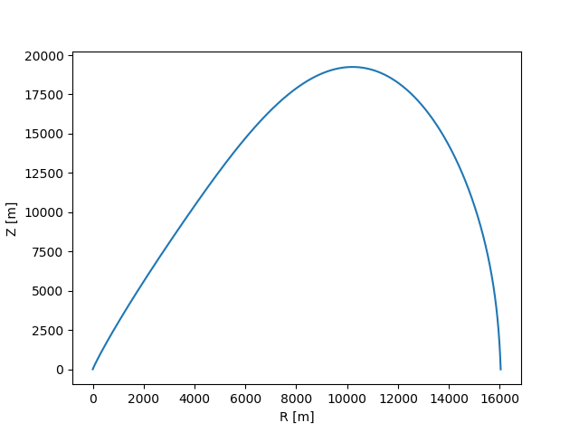

The rocket starts at (R,Z) = (0,4) m and increases its height approximately linearly with respect to range. This would mean that there is approximately zero net acceleration in the up and down direction.

At around 6000 m in range the rocket begins to experience a negative net acceleration due to drag and gravity, as there is no more fuel to produce thrust, and thus the curvature of the graph is negative.

At around 10000 m in range the rocket has reached its maximum height and is now falling. The fall is subject to gravity as its predominant force over drag and thus the rocket accelerates downwards, which is why the graph also curves downwards in this region.